**Level Design Document for:**

*Steampunk Level*

All work Copyright ©2022

Written by Sebastian Anderson

Table of Contents

1.0 Revision History 4

2.0 level Design Overview 4

2.1 Level Design concept 4

2.2 Gameplay Mechanics 5

2.3 Camera 5

3.0 Theme and Characters 6

3.1 Characters 6

3.2 Theme 6

4.0 Level Information 7

4.1 Level Location 7

4.2 Level Setting 7

4.3 Level Layout/Architecture 7

5.0 Level Design 10

5.1 Main Objectives 10

5.2 Optional Objectives 10

5.3 WOW Moments 10

5.4 Level Progression 11

5.5 Player Experience 11

6.0 Art Style and Aesthetics 12

6.1 Lighting 12

6.2 SFX/Music 12

6.3 Particle FX 12

6.4 References 13

7.0 Level Asset List 14

8.0 Delivery Milestones 21

9.0 Feedback 22

09/08/22 22

10/08/22 22

# 1.0 Revision History

<As you revise the document, list what was changed and when it was changed>

|  |  |
| --- | --- |
| Version | Description |
| 1.0 | Initial document |
| 1.1 10/08/22 | Changes to topographic map and level plan   * Removed the giant crowd from the center of the city * Replaced with a crash site and rubble to instead push the player in another direction |
| 1.2  11/08/22 | Redesigned the alleyway to be larger   * Alleyway is not much larger allowing a larger area to be explored * Alleyway now has a room hidden in the rubble where players can find an optional book to pickup |
| 1.3  12/08/22 | Redesigned the underground area, added a new bend where you fall into it, as well as added an extra area where the player can dip into to avoid NPCs |
| 1.4  12/08/22 | Redesigned the workshop district at the end   * Added a vertical challenge with enemies to avoid along the way * Moved the rooftop viewpoint backwards for a better view of the courtyard and generator |
| 1.5  15/08/22 | Received feedback that some lights led player in the wrong direction, and other paths needed to be better lit for the player to be drawn towards it   * Removed lights from un reachable locations and lit up paths with street lights and fires |

# 2.0 level Design Overview

## 2.1 Level Design concept

A short sequence, the player arrives on the main street of the giant city, the street just recently had rioters go through it, leaving rubbish and rubble everywhere, the rioters are trying to have the giant generator in the middle of the city turned off, the player decides to take a closer look and follows the main path, they don’t get far as not long down is a car crash that has blocked off the road and the player must find another way, they find an alleyway with old broken down buildings, it is full of thugs and the player must avoid them if they want to get past, they come up to a small bridge which breaks when the player walks across, the player is now in an underground workers tunnel, the tunnel is also full of thugs the player must avoid, these thugs move on paths and make the level more difficult to get around, the player gets to the end of the tunnel and finds a ladder, the player climbs the ladder and arrives in a workshop district not far now from the city square, . And the sequence ends.

## 2.2 Gameplay Mechanics

The player will be able to run, climb ladders and the ability to crouch to stealth past dangerous enemies through this sequence.

The character will also be able to collect collectibles around the map, there will be an option to interact with these objects when they find them

## 2.3 Camera

The camera will be in first person view

# 3.0 Theme and Characters

## 3.1 Characters

Main Character – In this sequence you play as a young adult (22 years old) living in a steampunk world

Thug – a Thug character who will act as a guard throughout the level, players will have to avoid this character to progress through the level, they wear colored overalls and a cap (some wear red some wear black), they are covered in soot and grease. If players get too close to these characters, the thug will chase the player until they catch them, and players will have to restart the level.

## 3.2 Theme

Set in a steampunk megacity in the year 1845, there is a giant generator in the middle of the city, visible from almost everywhere, the city is in the middle of a riot/ revolution to turn off the giant generator as it is polluting the city to an extreme and causing poorer parts of the city to get sick and suffer.

# 4.0 Level Information

## 4.1 Level Location

Set in the center of the Steampunk Megacity it has a giant generator in the center, visible from almost everywhere in the city, the scene features the main road, a dirty alleyway, an underground workers pass, and then a worker district with a large building with a rooftop the player can climb to.

## 4.2 Level Setting

The scene is set just before sunset, in a steampunk megacity, the year is 1845, Streets are filled with steampunk machinery, vehicles parked on side, the surrounding buildings are filled with shops, the streets have a lot of rubbish scattered around, there are no people in sight.

## 4.3 Level Layout/Architecture

The architecture is made tall apartment complexes, with stores at the bottom, the buildings are dirty, with lots of pipes and cogs climbing the exterior, the buildings, and streets and dirty and uncleaned, the buildings have small windows all over them

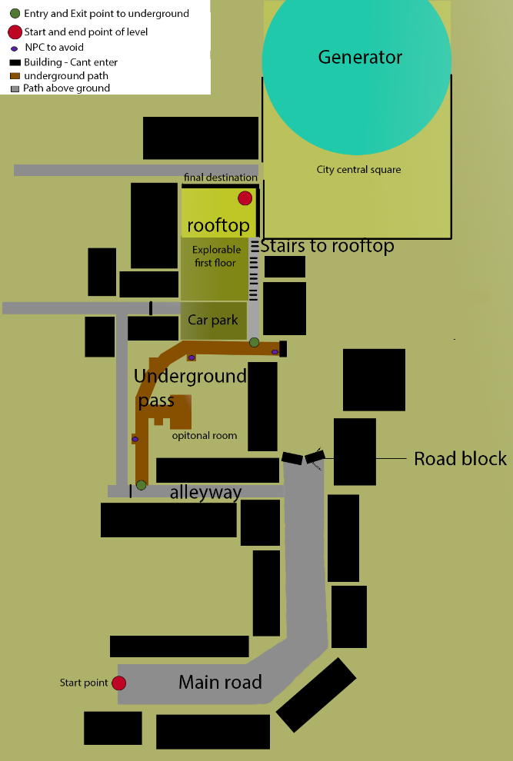Old topographical Maps version 1.0 & 1.1

Latest topographical map version 1.4

# 5.0 Level Design

## 5.1 Main Objectives

The player is exploring a giant city and is climbing to a rooftop to get a better view of the riots happening in the city

The player must also get through the level without getting detected by the NPCs

## 5.2 Optional Objectives

There are 3 different rooms that the player has the option to explore, and there are 7collectibles scattered around the map

* Broken building
  + A broken room to the right when the player enters the alley, lit up by a dim light, has a collectible inside
* Underground room
  + Has a piece of paper collectable the player can read for more optional story of the city
* Large shop building
  + There is a collectable the player can find inside the shop building on a table

## 5.3 WOW Moments

**First** wow moment when the player can see the enormous generator in the distance for the first time, when the reach the first corner of the main road.

**Second** Wow moment when the player reaches the destination on the rooftop and has a clear view of the generator and the surrounding city

## 5.4 Level Progression

*The game is simple to complete until the player reaches the underground pass, and the difficulty increases as the player must get to the next checkpoint (the ladder) without getting detected by NPCs along the way*

## 5.5 Player Experience

*The player is motivated by their friend to pursue them, they are promised with a glimpse of the generator close to the start of the generator, and are told they can get a better look at it and view over the city, the player then moves into a dark alleyway away, in the wrong direction of the generator, the player falls into an underground pass they can explore and navigate while having to avoid detection and once they beat the level they are rewarded with a great view of the city and the generator and celebrations happening below.*

*The player has multiple glimpses of the generator before they get a good look, first at the first bend in the road, then they get a peak of it when climbing up the ladder out of the underground pass, and finally they get a good look at the final checkpoint.*

*----- Beat sheet version 1.0 ---* ***Old***

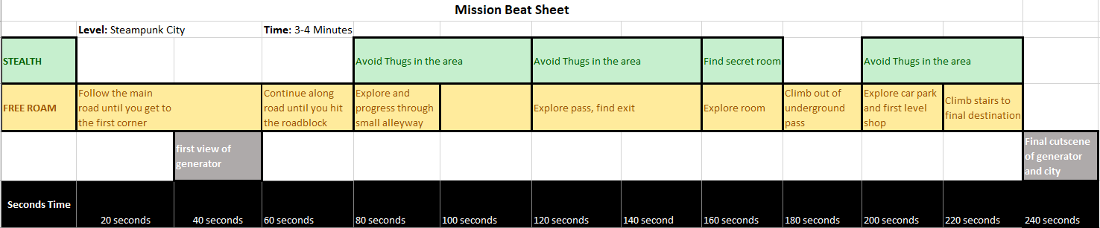 **Current Beat sheet version 1.4**

# 6.0 Art Style and Aesthetics

Refer to the Mood Boards and 2D level Design maps

## 6.1 Lighting

Main street is brightly lit, buildings are built out of darker colours, eyes should be drawn towards billboard on top of building furthest away from character when they spawn in, street is mainly lit up by streetlights

The small Alleyway is darker than the main street, the buildings and rubbish in the alleyway use colder tones, lit up mostly by fire bins rather than streetlights with give a darker tone on the environment

The underpass has bright lights, machinery in the underpass are colored brown and bronze colors.

## 6.2 SFX/Music

Ambient music – chill steampunk

SFX

Steam coming out of pipes

Footsteps

Cogs rotating

Crackling fire

## 6.3 Particle FX

Short bursts of steam – coming out of pipes in underground tunnel, used for environment detail and building the scene

Fire particle effects – for bins

Smoke particle effects – for chimneys and rooftops / generator

Spark particle effect – for broken cogs

## 6.4 References

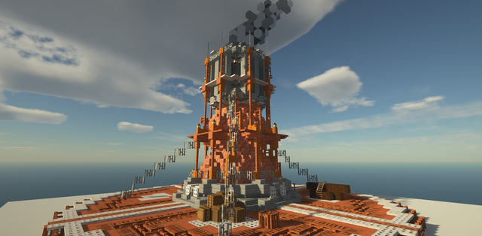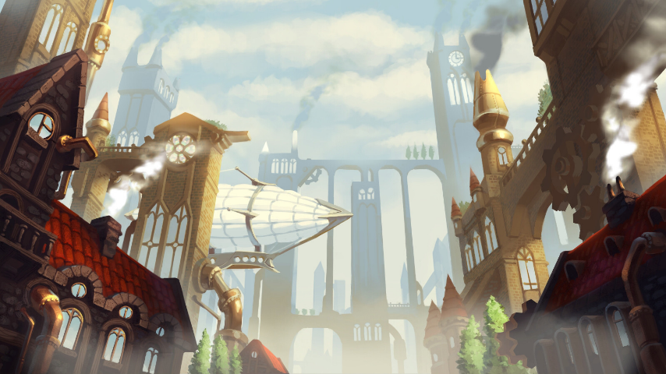

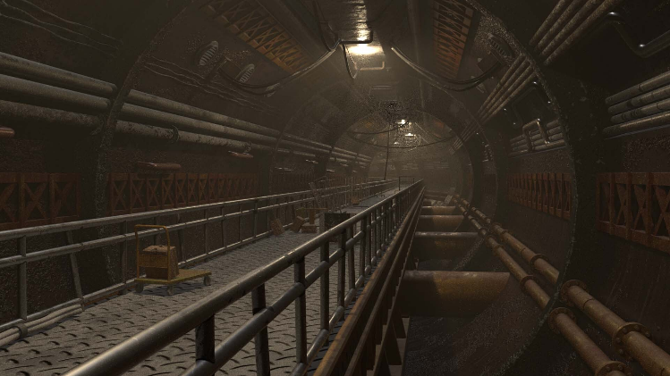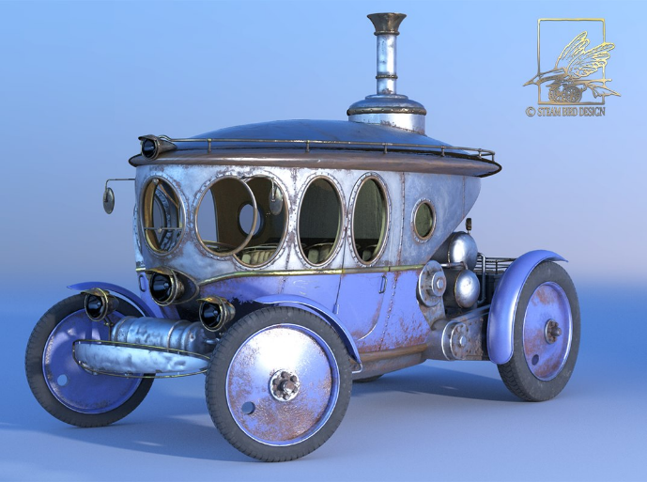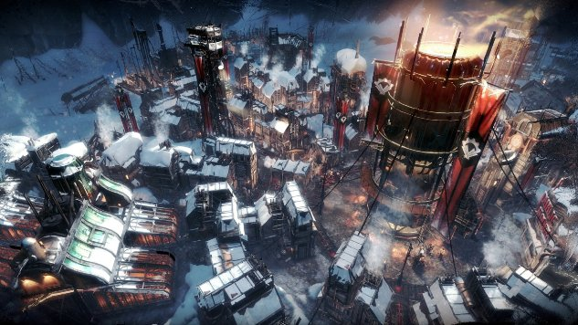

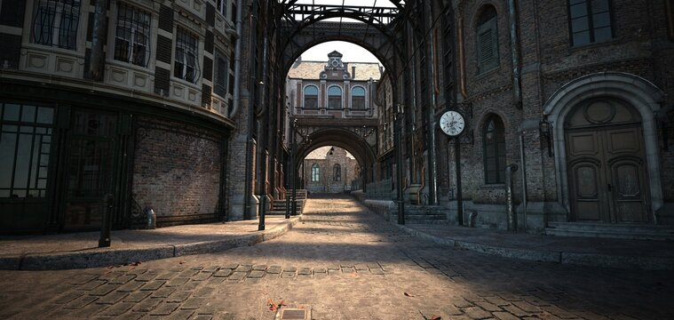

# 7.0 Level Asset List

Priority:

High - required for game to play Medium – not required, but scene will be empty without Low – a nice extra / decoration

|  |  |  |  |  |
| --- | --- | --- | --- | --- |
| Item | Variations | Programming | Art | Description |
| Car | 2 - colours | None – static | Bronze metallic, – 2m long 0.75m tall | Luxury steampunk car, static, with steam pipes surrounding bonnet, (example in reference) |
| Car 2 | 2 – colours | None – static | Silver metallic, 1.5m height, 2m long | Larger steampunk car, Cheap looking, simple shape (example in ref) |
| Ladder | 1 | When activated players climb to top | Dark grey metallic texture – 4m tall, 0.5m long | A ladder in the underground tunnel, cheap metallic, for workers |
| Trash bin | 1 | None – static | Green, 1m tall, 0.3m radius | Industrial, metal, Bronze, 6m |
| Modular Exterior wall | 2 – colours 1 – dirty texture | None – static | Flat wall with solid color 1x1m | A white wall and dark red wall, solid color with small markings for details (scratches) + dirty wall |
| exterior Widow | 2 – one arched another square | None – static | Not opaque, dark blue colored glass window | 2 variations of windows, players can’t see through, relatively basic look, with metal bars going through the center |
| exterior Doorway | 1 | None – static | Same red color as one of the walls colours, and size, hole in the middle for a door | Only need one, Red of white (like walls) needs a hole in the middle the same size as the double doors |
| Single Door | 2 variant Colours | None – static | bronze metallic material other out of silver metallic 1m long 2tall | Metallic door with large, rounded trim around it |
| Double Door | 1 | None – static | Made from wood material 2m long 2m tall | Simple wooden double doors, old and plain |
| Boxes | 2 variant sizes | None – static | Wooden boxes, 0.5x0.5m completely wooden and 1x0.5 with a cloth cover on top | Two different sized boxes, one cube and the other a longer box with the same height, the cube is plain and the other has a cloth cover on top |
| Ventilation grid | 1 | None – static | Simple metal bars in a grid, plain, silver metallic 1x1m | Silver slightly rusty metallic grid bars, for blocking off the ladder, and the player will push away |
| Worker | 1 | AI walking animation and working animation, + path to walk | Man, covered in soot and grease, wearing blue overalls and blue cap | Man In the underground area, doing minor work tasks in the area as player has to sneak past |
| Railing pieces modular | 2 different shapes | None -static | Dark grey metallic color, 1m long 0.5m tall one has a 90-degree bend halfway along | Used as guides in underground path, also used as decoration pieces in the street |
| Exterior staircase | 1 | None – static | Rusted metal, 1m wide, modular pieces | Outdoor staircase, rusted metal, attached to the side of a building |
| Streetlight | 1 | None -static | Dark grey metallic pole, spherical top of glass where light is | Attached light to the glass at the top, emits bright blue-white light |
| Cogs | 2- size variation | Slowly rotating 360 degrees | Bronze colored circular cogs, low detailed and not intricate | Cogs are used as decoration pieces on some of the buildings as well as in the underground tunnel |
| Modular Large Pipes | 3 shape variation | Static – none | Bronze pipes, 1 straight horizontal pipe 0.5m long, 0.2 tall, another with a 90-degree bend in the middle and third is straight but has a hole in it | Bronze pipes used as map decoration to build the environment, the pipe with a hole in it will have a steam emitter attached to it that periodically spits out a steam burst |
| Underground Tube - modular | 1 | Static – none | Concrete tube, the player is inside underground, dark brown color, has a circle beam on either side of it (example pic in references) | The tube the player will be inside when they are in the underground tunnel, dark atmosphere, dirty and covered in damage and scratch marks |
| Modular small pipes | 2 | None – Static | Bronze pipes, small radius wide, one with a 90-degree bend halfway down | Small decorative pipes, |
| Modular Concrete beams | 2 | None – static | Light Grey concrete beams, for building decoration | 2 different sizes, 1 4m long another 6m long |
| Park Bench | 1 | None | 2m long, 1m wide, stone park bench, thick solid structure | Cheap stone park, one thick slab on top, |
| Riot Sign | 2 | None | Wooden pole and white cardboard sign, red text | Riot signs that litter the main road, voicing the poor people, saying “can’t breathe and turn off the generator |
| Billboards | 2 | None | Billboards in bright warm colours, that promote the generator stating all the good things it will do. | Large billboards that sit on giant buildings or on rooftops |
| Chimney | 1 | None | Large brick chimney, puffs out thick black smoke into the city | Will have a particle effect attached with black smoke coming from, 2m tall, built out of bricks |
| Table | 1 | None | Small rounded wooden table for 2 people to sit out, outside table | Round wooden table, cylinder top with a wooden stand in the middle, for 2 chairs to sit either side, 1m wide |
| Chairs | 1 | None | Old Metal chair, for dining outside at a cafe | 0.4m base and 1m tall back of chair, |
| Giant Clock | 1 | None | Old clock, white and black, metallic textures | Large clock to be attached to the side of large buildings |
| Red light | 1 | Light that flashes on and off after a delay | Small glass cube that emulates red light | – 0.2x0.2m attaches to gates to show that a dangerous event is happening in the city |
| Broken wall | 3 – different shapes | None | Brocken brick walls, with jagged edges in different places | each piece is different but is modular so that they can be put together at different angle and line up correctly |
| Broken bricks | 2 – varying sizes | None | Small brick pieces that are broken up | To be scattered around the map to represent rubble, seen piled up around broken walls |
| Wall poster | 2 – varying sizes | None | Posters on the wall of upcoming events, use bright colours but make them look old & dirty - been on the wall a while | 2 different posters of different sizes, 1m tall one and a 0.5m tall one – just as background images to bring the scene to life |
| Collectible postcard | 1 | Particle effect of glowing sparkles, when player presses button adds it to collection | Old postcard, with bright colours, and scribbled unreadable text on it | Collectibles that can be found around the map, some in more difficult locations to find than others |
| Railing | 1 | None | Metal railing, dark grey coloured, around 0.5m tall | For roadside railing as well as on top of high places |
| Wall decoration | 2 | None | Thick concrete slabs, with points coming out of the edges, 2m wide | Concrete slabs used as decoration for walls, to break up windows and sections of the building |
| Building tower | 2 | None | Square blocks with a pointed roof, block is same texture as wall, with a roof texture on top | Used as towers on top of buildings to make them more interesting |
| Roof top | 2 | None | A pointed roof with black tiles, and a rounded glass rooftop | Modular rooftops for different buildings, one glass and one with cement tiles |
| Gate | 1 | None | Vertical Metal bars, with one horizontal bar at the bottom, metallic texture | For the gateways for access onto the main road, large structure that vehicles can fit under |
| Stairs | 1 | None | Stone staircase, that climbs 1m high, each step is 0.1m tall | Modular stair piece, with triangular walls either side of it, 1x1x1m dimensions |
| Flag | 1 | Animated swaying in wind | Cloth flag with simple flag design red with blue cross in middle on a metal flagpole | Flag that sits on top of tall buildings, slowly swaying in the wind, flag is red with a blue cross through the middle |
| Broken fountain | 1 | None | A concrete park fountain, with half the structure in the middle broken away, | A concrete statue in the middle that has been broken in half,  water surrounding the middle structure, |
| Fountain top | 1 | None | The top of the broken concrete fountain, with a steel chain tied around it | The top of the fountain has been dragged away by a nearby car that crashed, so the chain tied around will be linked to the car nearby |
| Giant Generator | 1 | None | A dark grey generator, rusted colour added, with graffiti on the left side, has bolts along the sides and a large circle in the middle | Giant center piece of the scene, has thick black smoke coming out of the scene, littered with red lights, and lit up by lighting in the scene |
| Street sign | 2 – one is a broken version of the other | None | Large street sign that sits over the top of the road, has street name and directions on it, coloured green with metallic legs | Large and covers road, sits over the top of it, one of the variations is missing a leg and will be laying down in the scene |
| Entrance to subway area | 1 | None | Green metal structures, with concrete stairs and another green door down the bottom | Hollow subway entrance with a door blocking player, you can see through the windows and down below where there is stairs leading to another doorway |
| Cashier desk | 1 | None | A large counter with a wooden rim on top, the block is concrete, top is wooden | Used inside the workshop district, there is a room you can enter, and a counter on the right, 2m wide |

# 8.0 Delivery Milestones

<Provide milestone dates for Prototype, Testing Phases and Final Build>

**Prototype:** First prototype will be finished Saturday (13/08) this will be a completely grey boxed level, with an animated friend that will guide you through most of the level, there will also be workers in position that are activated if the player comes too close to them.

**Testing and Iteration:** Testing will be done from Sunday the 14th until Tuesday the 16th,

testing will be done to ensure the level plays smoothly and the player is guided naturally and correctly through the level, it will also test the difficulty of the game and fine tune the stealth aspect.

**Final Build:** From the 16th the final build will be polished and tidied up until it is ready to submit on the 18th

# 9.0 Feedback

## 09/08/22

* Showed the Level and topographical map idea to Dan
  + Dan suggested that the level design wasn’t very complex, lots of straight lines as well as the large crowds could be difficult to implement into the level as it is quite expensive to run large amounts of characters
    - I changed the map to have more interesting locations, added more optional things to explore and gave a reason for players to go looking around by adding collectibles around the map
    - I also removed the large crowd from the main street and replaced it with a car accident as an obstacle to move the player in another direction

## 10/08/22

* Presented the entire LDD to Kay for review
  + Kay said that the optional objectives had been placed in the WOW moments section as I misunderstood what was required, as well as the asset list was missing a few key items for later parts in the level, including underground modular pieces, and items found inside the shop area
    - I redid the optional and WOW objectives of the document, so that it fit the requirements,
    - I also redesigned the asset list to have more information for each object and added each object that would be in the scene.

## 15/08/22

* Presented the Greybox level to Dan for testing
  + Received feedback that there were multiple areas where the player could jump into the void if they tried hard enough, some rooms were not well decorated compared to others and some lighting issues caused the player to be drawn towards the wrong areas
    - Removed lights where the player was not able to reach
    - Added decoration to rooms that were undecorated
    - Added invisible box collisions to areas where the player shouldn’t be able to go